Live Q&A 3 Transcript
[pardon my handwriting!]

Preliminaries
- If you missed last week, please attend the replacement session if you can!
- Thanks to everyone that submitted the feedback form on KEATS. The poll closed yesterday night but I promise that by next week we will discuss it.
- This week you are asked again to give feedback on the SGTs

Exercises

3.3 For each of the following functions, determine whether…
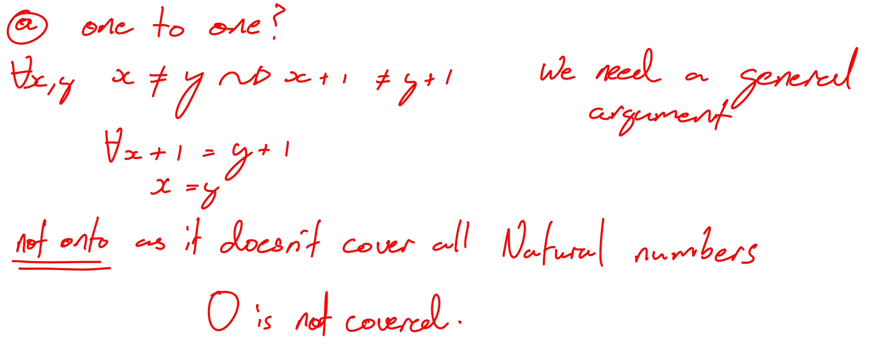
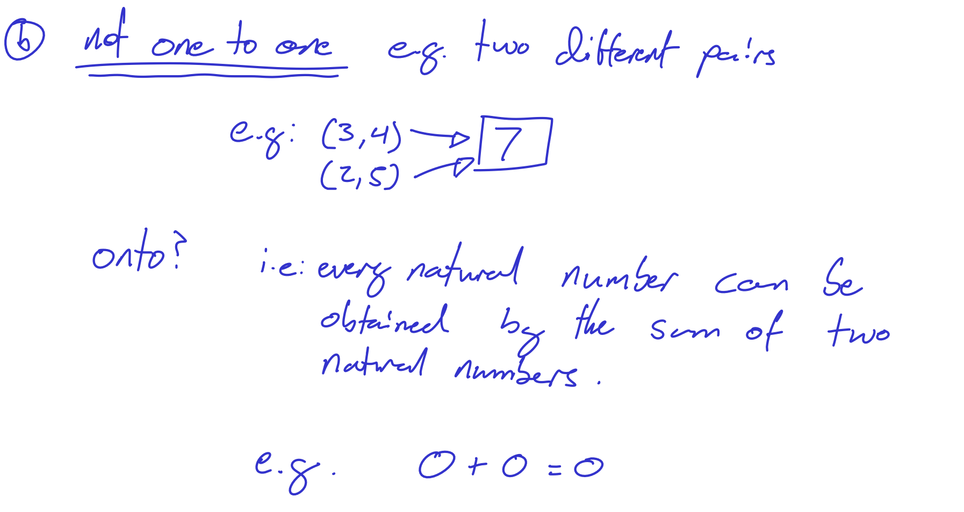

3.4 Give an example…
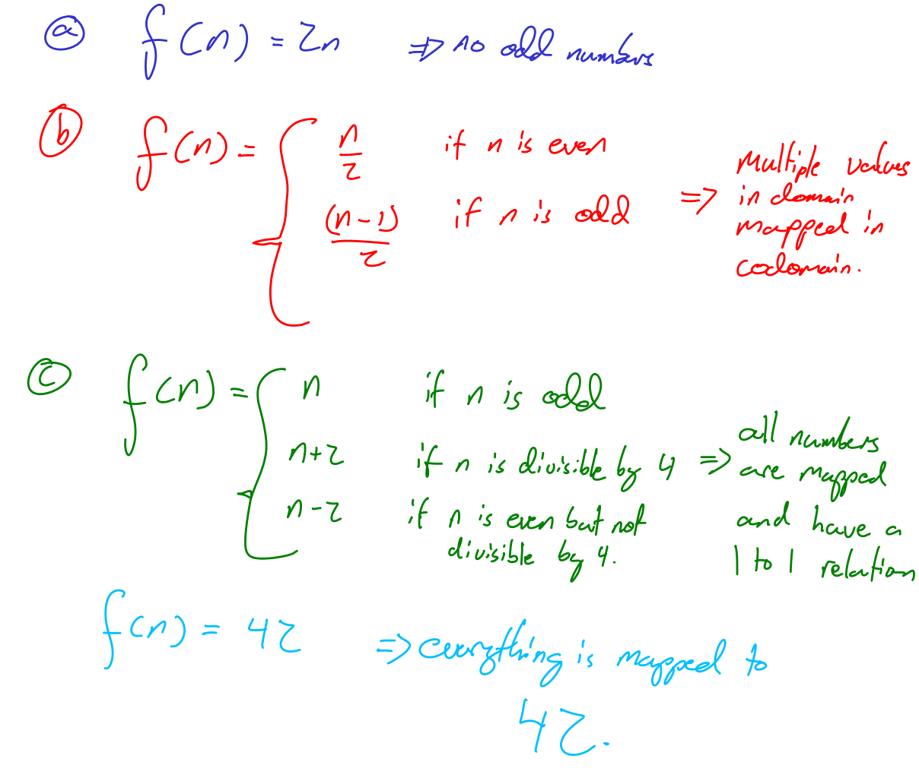

3.5 Let f and g be…
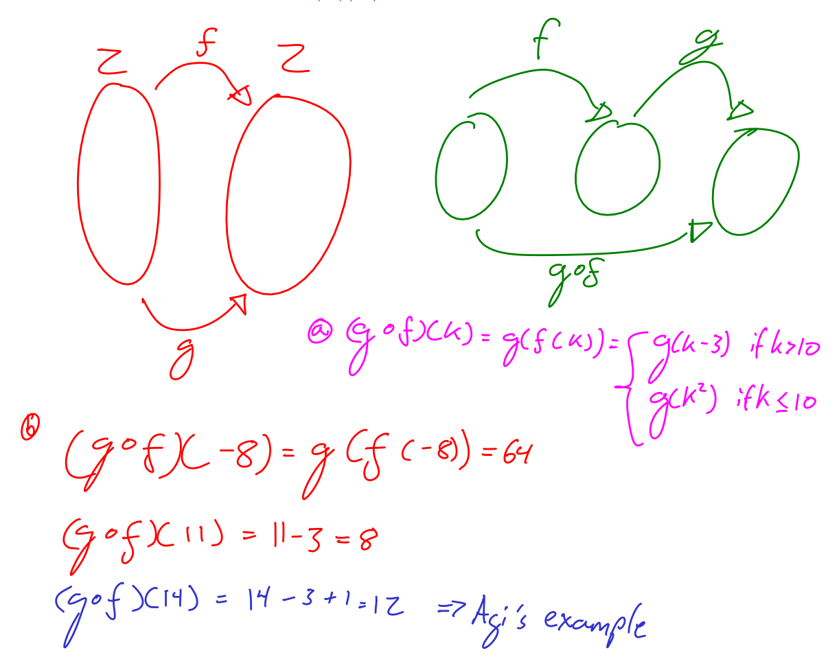

3.7 Prove that Z is a countable set by...
